

**CSC584 - ENTERPRISE PROGRAMMING**

**GROUP PROJECT:  
University Club Management System**

**GROUP 7**

|  |  |
| --- | --- |
| **MUHD REDZUAN BIN ABD MALEK** | **2024861528** |
| **MOHD IFFIAN BIN ABU BAKAR** | **2024793277** |
| **MUHAMAD HAFIFY BIN NOR RAMAN** | **2024724471** |
| **MUHAMMAD HAZIQ IMRAN BIN BORHAN** | **2024748143** |
| **ANAS BAHARI BIN MOHAMED MUSLI** | **2021719989** |

**LECTURER**

**MR MUHAMAD RIDHWAN BIN MOHAMAD RAZALI**

**TABLE OF CONTENT**

|  |  |  |
| --- | --- | --- |
| **UNIT** | **TOPIC** | **PAGE NO.** |
| 1 | Introduction | 1 |
| 2 | Problem Statement | 2 |
| 3 | Objective | 2 |
| 4 | System Modules and Features  4.1 Login Page 4.2 Register Page  4.3 Student Dashboard 4.4 Browse Available Clubs Page 4.5 Apply to Club Page 4.6 Admin Dashboard 4.7 Manage Application Page 4.8 Manage Events Page 4.9 Manage Clubs Page | 3  3  4  5  6  7  8  9  10  11 |
| 5 | System Workflow | 12 |
| 6 | Security Features | 12 |
| 7 | Conclusion | 13 |

1. **Introduction**

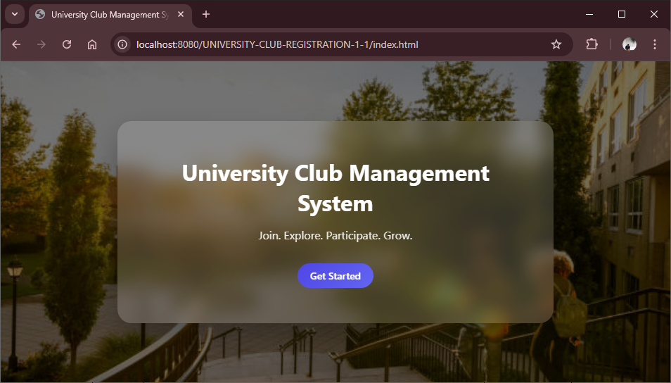

The University Club Management System is a web-based application developed to simplify and digitalize the management of university clubs, student applications, and event organization. Traditionally, club registration and event management processes are handled manually, leading to inefficiencies, data redundancy, and delays in approval processes.

This system provides a centralized platform where students can register, apply for clubs, and view upcoming events, while administrators can manage applications, clubs, and events efficiently. The system is developed using Java Servlet, JSP, and Apache Derby Database.

1. **Problem Statement**

Many universities still rely on manual or semi-digital systems for managing student club activities. This leads to several issues:

* Manual processing of club applications causes delays.
* Difficulty in tracking application status (Pending, Approved, Rejected).
* Poor event visibility among students.
* Data duplication and inconsistency.
* Lack of centralized control for administrators.

Without a structured system, both students and administrators face inefficiencies in managing club memberships and events.

1. **Objective**

The main objectives of the University Club Management System are:

* To develop a secure login system with role-based access (Student and Admin).
* To allow students to register and apply for clubs online.
* To enable students to view their approved clubs.
* To display upcoming events dynamically.
* To provide administrators with tools to manage applications efficiently.
* To allow administrators to create, edit, and delete clubs and events.
* To maintain organized and structured database records.

1. **System Modules and Features**

**4.1 Login Page**

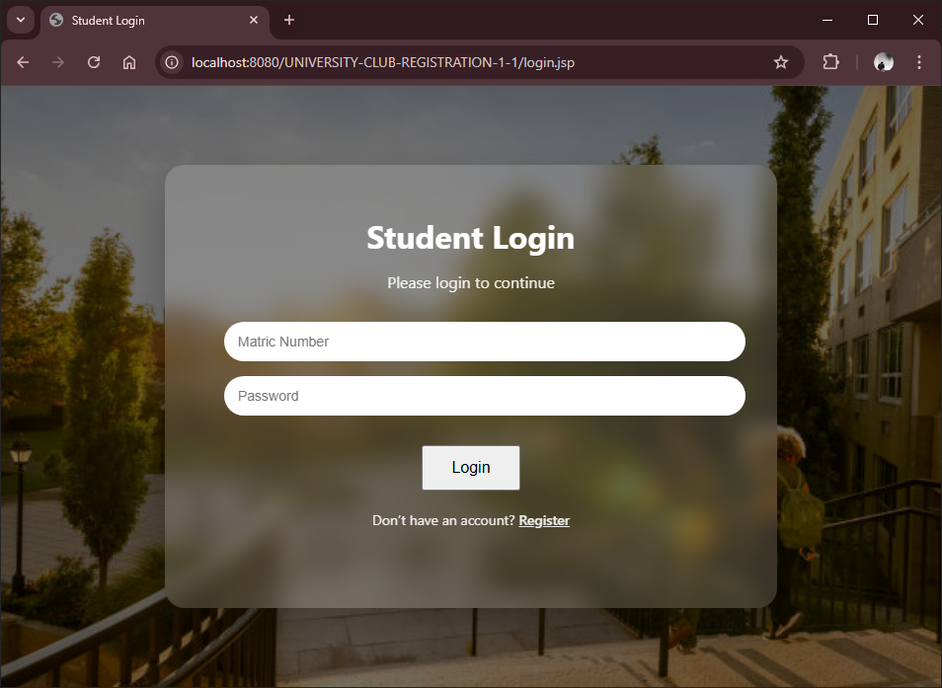  
Purpose:

Allows registered users (Student or Admin) to access the system.

Functions:

* User enters Matric Number and Password.
* System verifies credentials.
* Redirects based on role:
  + Student → Student Dashboard
  + Admin → Admin Dashboard

**4.2 Register Page**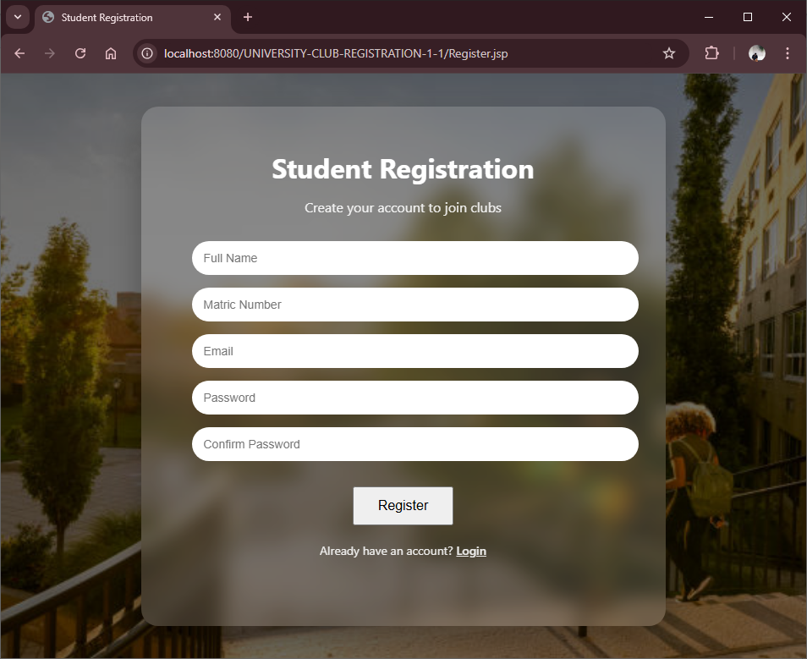Purpose:

Allows new students to create an account.

Functions:

* Enter matric number, name, and password.
* Account information stored in the database.
* User can log in after registration.

**4.3 Student Dashboard**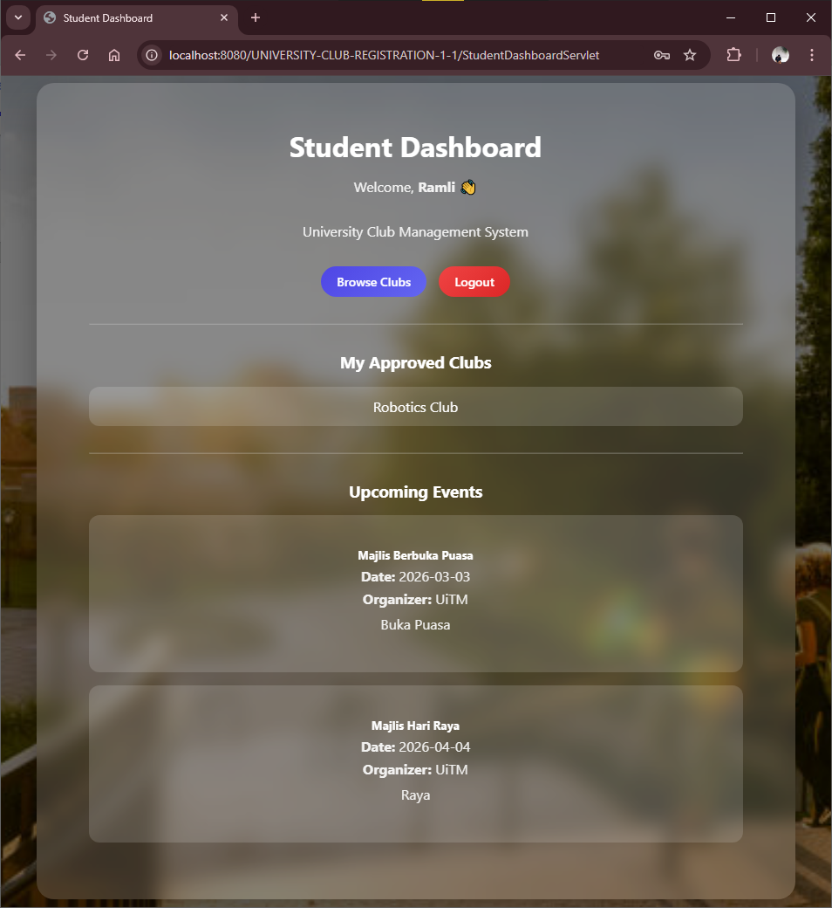Purpose:

Main page for students after successful login.

Features:

* Displays "My Approved Clubs".
* Displays "Upcoming Events".
* Navigation options:
  + Browse Clubs
  + Logout

Students can easily monitor their club memberships and upcoming activities.

**4.4 Browse Available Clubs Page**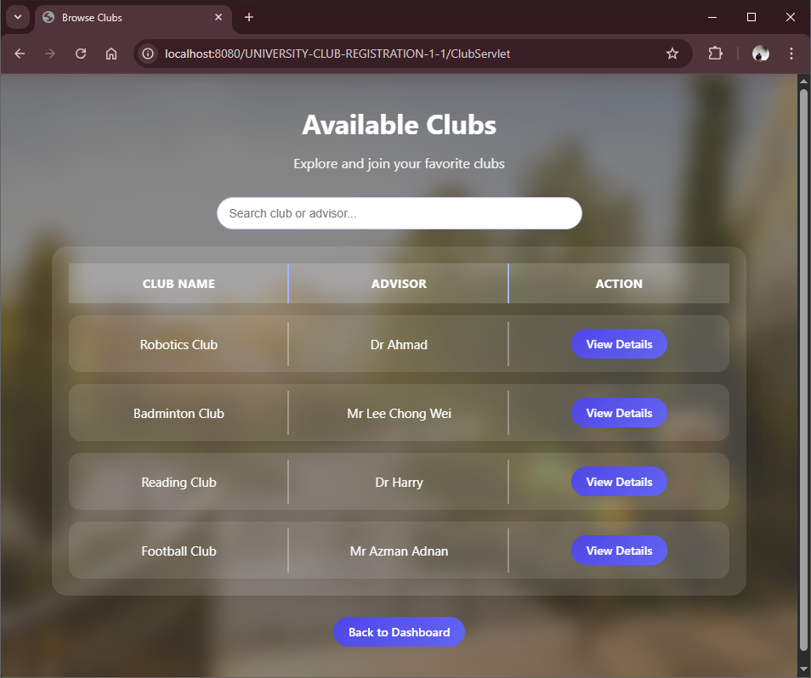Purpose:

Allows students to view all available clubs.

Features:

* Displays club name, advisor and View Details button.
* Students can scroll to search for clubs.

**4.5 Apply to Club Page**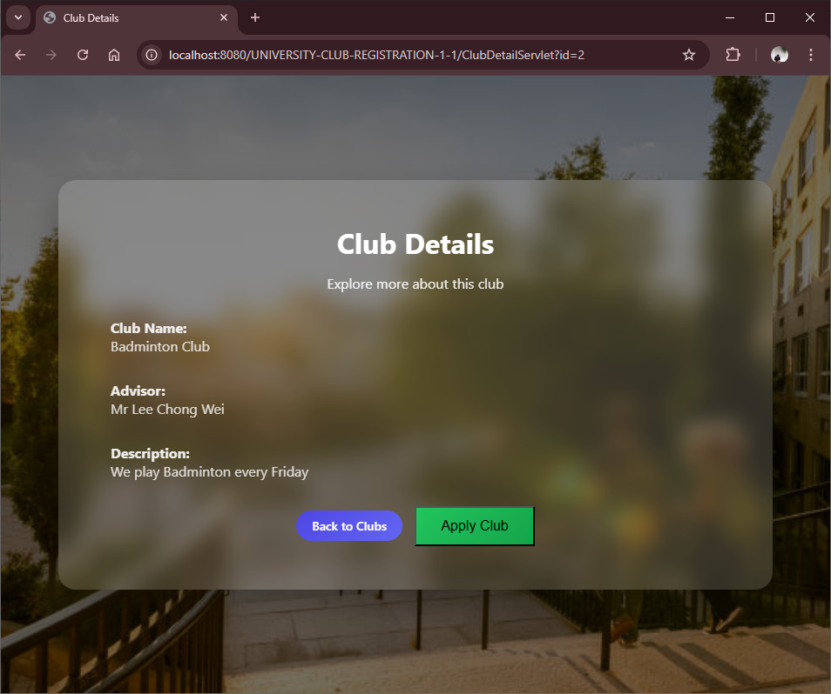Purpose:

Submit application to join a club.

Process:

* Student clicks Apply Club.
* Application stored with status = "PENDING".
* Awaiting admin decision.

**4.6 Admin Dashboard**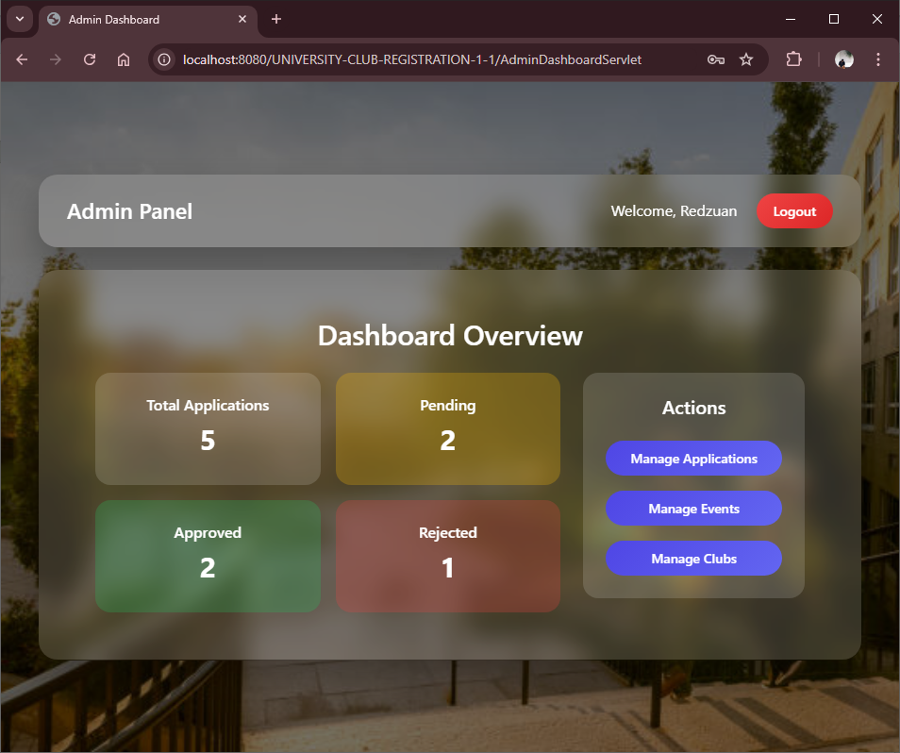Purpose:

Control panel for administrators.

Displays:

* Total Applications
* Total Pending Applications
* Total Approved Applications
* Total Rejected Applications

Navigation options:

* Manage Applications
* Manage Events
* Manage Clubs
* Logout

**4.7 Manage Application Page**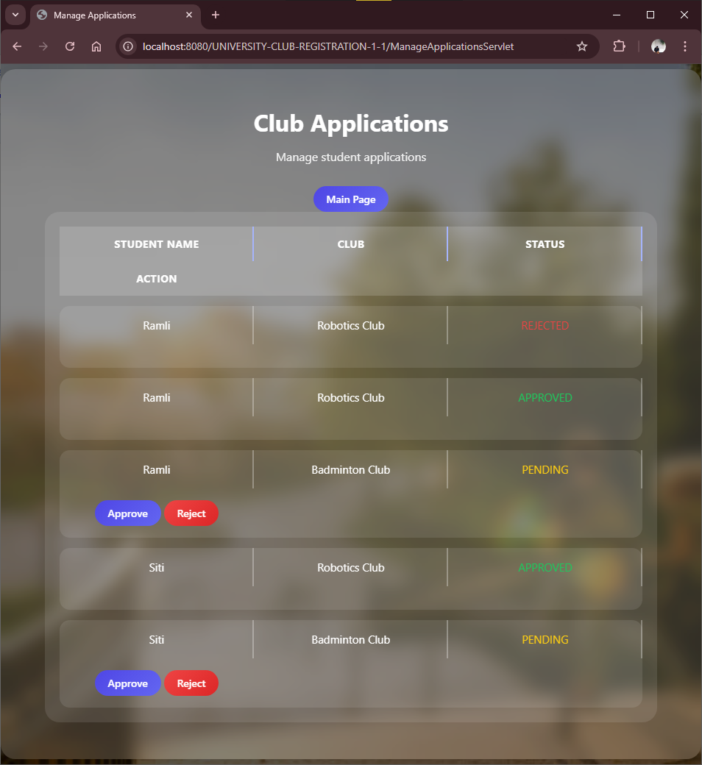Purpose:

Admin reviews student applications.

Functions:

* View student details and selected club.
* Approve or Reject application.
* System updates status accordingly.

**4.8 Manage Events Page**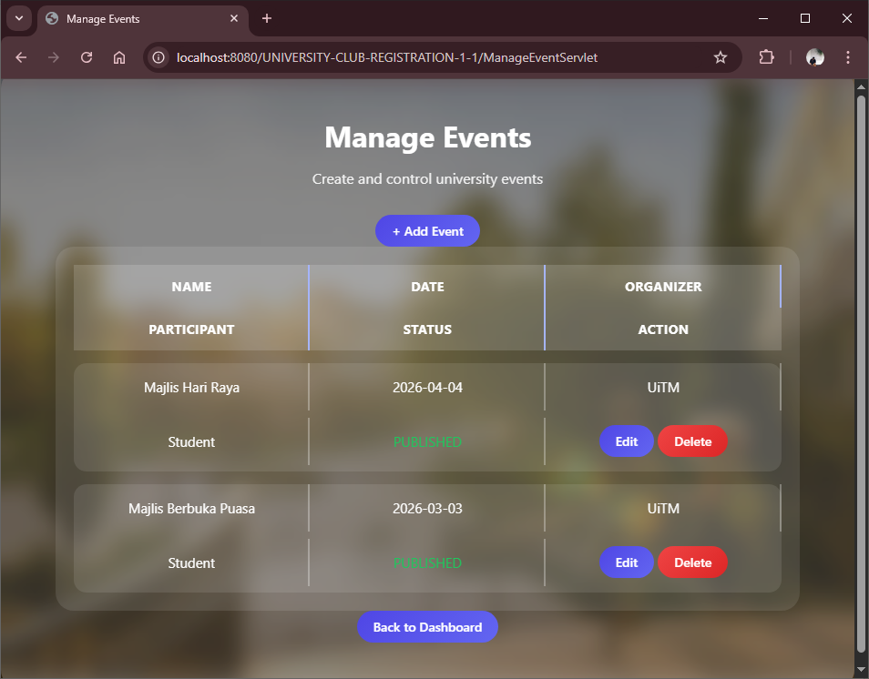Purpose:

Admin manages club events.

Functions:

* Create new event
* Edit event details
* Delete event

Event details include:

* Event Name
* Event Date
* Organizer
* Description
* Contact Person
* Status

**4.9 Manage Clubs Page**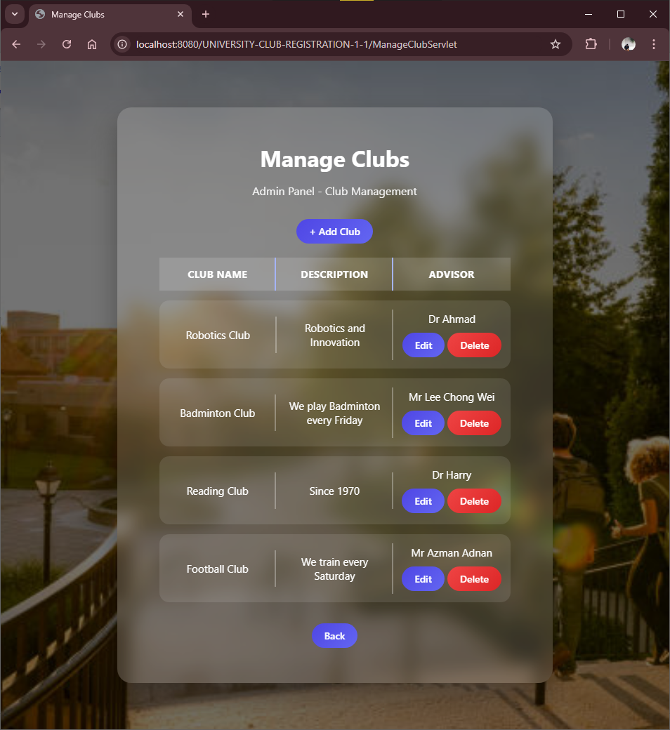

Purpose:

Admin manages club records.

Functions:

* Create new club
* Edit club details
* Delete club

1. **System Workflow**

* Student registers account.
* Student logs in.
* Student browses clubs.
* Student applies to club.
* Admin reviews application.
* Admin approves or rejects.
* Approved clubs appear in Student Dashboard.
* Admin creates events.
* Upcoming events displayed to students.

**6. Security Features**

* Role-based access control (Student/Admin)
* Session management
* Restricted access to protected pages
* Database integrity enforcement

**7. Conclusion**  
The University Club Management System successfully provides a structured and efficient platform for managing student club activities. It eliminates manual processing, improves application tracking, and enhances communication between students and administrators.

Through automation and database integration, the system increases transparency, reduces administrative workload, and ensures organized record management. This system demonstrates the practical application of web development technologies such as Java Servlets, JSP, and relational databases in solving real-world problems.

Overall, the project achieves its objectives and provides a scalable foundation for further enhancements such as event registration tracking, notification systems, and reporting features.